17 November 2025

To Whom It May Concern,

I am writing to provide a reference for Proshield Security, with whom we have had the pleasure of working since 1 September 2019. During this time, Proshield has consistently demonstrated professionalism, reliability, and a strong commitment to safety.

Their team of security personnel is well-trained, courteous, and proactive in addressing potential risks. We have found their services to be highly effective in maintaining a secure environment for our facilities and staff. Communication with their management has always been prompt and transparent, ensuring smooth coordination and quick resolution of any concerns.

Based on our experience, I confidently recommend Proshield Security to any organization seeking dependable and professional security services. They have proven to be a trustworthy partner who prioritizes client safety and satisfaction.

If you require further information, please feel free to contact me at 082 821 6402 or renata@nazarethcare.co.za

Sincerely,
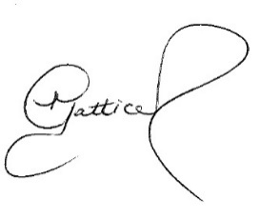
Renata Gatticchi – Facility Manager
NAZARETH HOUSE

